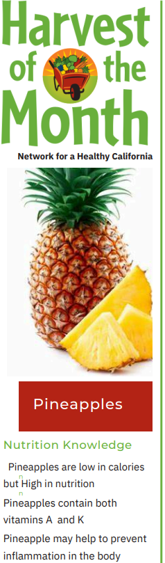
Monday 3 | Tuesday 4 | Wednesday 5 | Thursday 6 | Friday 7
WGR Corn Chex, Pear, & 1% Milk | WGR Honey Granola, Apple, & 1% Milk | Mini Bagel, Cream Cheese, Banana, & 1% Milk | WGR Bran Flakes, Cantaloupe, & 1% Milk | 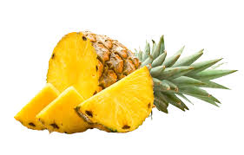English Muffin, Tropical Cream Cheese, Pear, & 1% Milk
Sicilian Meat Sauce over Penne Pasta, Caesar Salad, Orange, & 1% Milk | Jerk Chicken, Jasmine Rice, Sesame Slaw with Snap Peas, Honeydew & 1% Milk | BBQ Beef Burger on Sliced WGR Wheat Berry Mini-Bun, Chopped Salad, Orange, & 1% Milk | Herb-Roasted Turkey with Gravy, WGR Wheat Berry Roll, Mashed Potato, Banana, & 1% Milk | Maple Chicken Salad Sandwich on WGR Wheat Berry Bread, Tomato Basil Soup, Spring Salad, Orange & 1% Milk
Cilantro Hummus with Carrot Sticks & Water* | Cheddar Cheese Square, Wheat Crackers, & Water* | Herbed Cottage Cheese with Italian Crostini, & Water* | Sweet Potato Yogurt, WGR Graham Crackers, & Water* | Harvest Applesauce & 1% Milk
Monday 10 | Tuesday 11 | Wednesday 12 | Thursday 13 | Friday 14
WGR Rice Chex, Orange, & 1% Milk | WGR Corn Chex, Apple, & 1% Milk | WGR Toasted Oats, Banana, & 1% Milk | Mini Bagel with Apple Cinnamon Cream Cheese, Golden Apples, & 1% Milk | WGR Honey Granola, Pear, & 1% Milk
Maria’s Famous Chili with Wheat Crackers, Pear, & 1% Milk | Curry Chicken Salad Sandwich on WGR Wheat Bread, California Salad, Orange, & 1% Milk | Taco Salad with Beef, Beans & Corn, Romaine Lettuce, WGR Tortilla Chips, Pico de Gallo, Apple, & 1% Milk | Grilled Chicken, Spanish Rice, Rainbow Salad, Cantaloupe, & 1% Milk | Chicken Salad Sandwich on Wheat Bread, Spinach-Cranberry Salad, Orange, & 1% Milk NHA NS Closed
Cottage Cheese with Golden Raisins & Cranberries, WGR Graham Crackers, & Water* | Roasted Garlic & Rosemary Bean Soup, Wheat Cracker, & Water* | WGR Graham Cracker & 1% Milk | Green Monster Smoothie, WGR Graham Crackers, & Water* | Pico de Gallo with WGR Tortilla Chips & Water*
Monday 17 | Tuesday 18 | Wednesday 19 | Thursday 20 | Friday 21
WGR Corn Chex, Pear, & 1% Milk | WGR Toasted Oats, Orange, & 1% Milk  CAPSLO: Cinnamon Raisin Oatmeal | English Muffin, Cream Cheese, Orange, & 1% | WGR Rice Chex, Apple, & 1% Milk | WGR Honey Granola, Pear, & 1% Milk
Turkey & Cheese Sandwich, Potato Salad, Orange, & 1% Milk  NHA NS Closed | Stewed Beef with White Rice, Italian Salad, Banana, & 1% Milk | Shredded Beef Tacos with Pico de Gallo on WGR Whole Wheat Tortilla, Pear, & 1% Milk | Sundried Tomato Mac n Cheese with Smoked Paprika Chicken, Broccoli & Raisin Salad, Pineapple, & 1% Milk | Turkey & Cheese Sandwich on WGR Wheat Bread, Cream of Zucchini Soup, Orange, & 1% Milk
WGR Graham Cracker & 1% Milk | Apple, & 1% Milk | Southwestern Black Bean Dip with WGR Tortilla Chips | WGR Graham Cracker & 1% Milk | Arroz con Leche, Banana, & Water*
Monday 24 | Tuesday 25 | Wednesday 26 | Thursday 27 | Friday 28
WGR Rice Chex, Pear, & 1% Milk | WGR Corn Chex, Apple, & 1% Milk | English Muffin, Pineapple Cream Cheese, Honeydew, & 1% Milk | WGR Toasted Oats, Banana, & 1% Milk | WGR Bran Flakes, Orange, & 1% Milk
Turkey Cranberry with Sliced Tomato on WGR Wheat Berry Bread, Cream of Potato Soup, Orange, & 1% Milk | Rotini alla Bolognese, Caesar Salad, Orange, & 1% Milk | Lentil Soup with WGR Multi-Grain Roll, Spinach-Cranberry Salad, Cantaloupe, & 1% Milk | Pesto Pasta with Oven Baked Chicken, Roasted Turmeric Cauliflower, Honeydew, & 1% Milk | Bean Taco on WGR Corn Tortilla & with Pico de Gallo, Spring Salad, Apple, & 1% Milk
Blueberry Mint Smoothie, WGR Graham Cracker | Black Bean and Corn Salad with Tortilla Chips and Water* | Chocolate Butter, Apple, & Water* | WGR Graham Cracker & 1% Milk | Herbed Cottage Cheese with Wheat Cracker & Water*
  February 2025  EXTERNAL |  |  |  | Toddler Accommodations
Lettuce- Steamed Cauliflower
Spinach- Steam Broccoli
Pears- Soft pears
Apples & Apple Sauce
Tortilla Chips- Soft Tortillas
Carrot Sticks – Soft Carrots
Cabbage- Steam carrots
Water optional
Copyright © 2024 by The Neighborhood House Association (NHA). All rights reserved. No part of this document may be reproduced without the prior written permission of NHA

1

2

3

4



